Learning Tally with assignment

M/s Arjun ltd. Co.

2010 Oct:1 Arjun started a business with cash Rs. 10,00,000
Oct: 2 Received a bank loan from HDFC Bank Rs. 5,00,000
Opened a bank account with Bank SBT Rs. 2,00,000
Oct: 3 Bought Furniture from Furniture Mart Rs. Rs. 1,00,000
Advertisement payable to Media Advertiser Rs. 1,00,000 (Inv. No. 1284, due days 10 days)
Oct: 4 Paid printing charge Rs. 500
Bought Machinery Rs. 1,20,000
Oct: 5 Purchased goods from Aroma Traders Rs. 85,000 (bill No: 108)
Purchased goods for cash Rs. 10,000
Oct: 6 Telephone charge paid by SBT cheque Rs. 1800 (Ch No:123456789)
Oct: 7 Cash sales Rs. 50,000
Oct: 8 Goods returned to Aroma traders Rs. 5,000 (agst Bill No: 108)
Oct:10Cash paid to Aroma Traders Rs. 25,000 (Bill 108)
Oct: 11Sold goods to Kishore Rs. 40,000 ( Bill No: 2)
Oct: 12Cash received from Kishore Rs. 25,000 (Bill No: 2)
Oct: 13Goods returned from Kishore Rs. 5,000 (Bill No: 2)
Oct:15Cash withdrawn from SBT Bank Rs. 10,000
Oct: 16 Paid loan of HDFC Rs. 1,00,000
Oct: 17 Cheque of Bank SBT issued to Furniture Mart Rs. 50,000
Oct: 18 SBT Cheque issued to Media Advertiser Rs. 50,000
Oct: 25 Cash withdrawn from SBT Bank for personal use Rs. 5,000
Oct: 30 Paid salary Rs. 12,000

How to create company
Double clicking on the tally icon will open tally.

Tally opening screen will look like as follows.

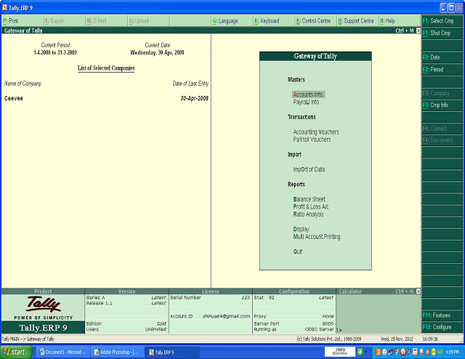
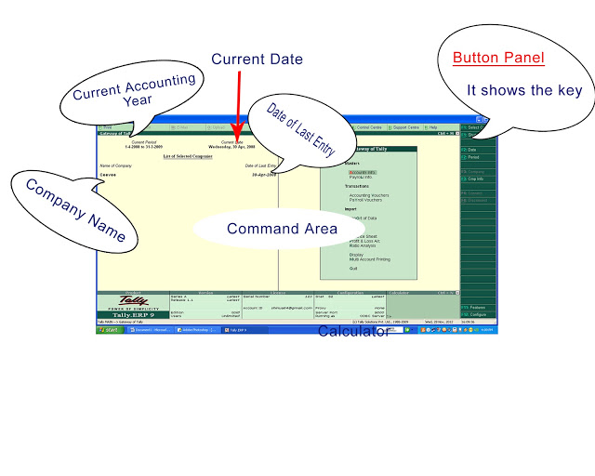
From here press Alt + F1 (to shut company)
Then select the option create company.

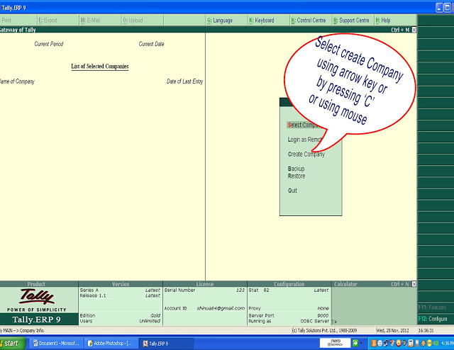
Insert the following details.
Directory: C:\ Tally .ERP9 \ Data (this is the default directory and folder. if necessary you can change this at the time of tally software installation or you can directly change from the creation window. (d:\ Tally\Data) i.e., you only type the path or drive where you want to store your data)
Name: M/s Arjun Ltd.( ie, company name )
Address
Select the country and state
Give Pin code,telephone no, mobile no and e-mail address
if you want auto back up then, Enable auto backup Yes
Currency symbol
Maintain- Accounts only or accounts with inventory. (Specify whether you want to maintain only financial books of accounts or both accounts and inventory)
If you want to give inventory details, then you should select Accounts with inventory
Then give Financial Year and Books beginning
Financial year from ( Tally considers 12 months from the date you give here as the Financial year 01/01/2010)
Books beginning ( in this case, it is 01/10/2010)
Tally Vault Password: here you can give a password
Use Security Control: If you want to control over accessing tally data, give Yes
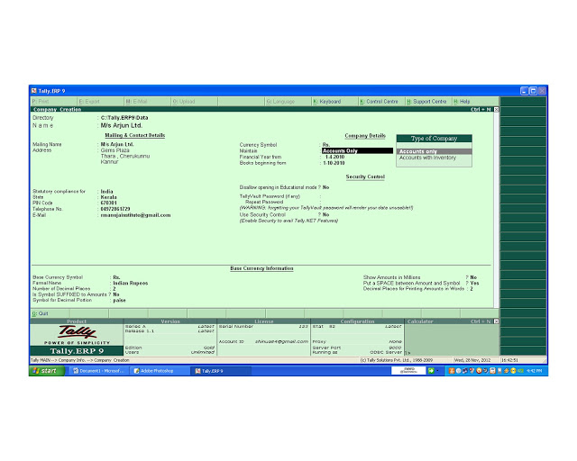
Your company is created. Then you can see the Gateway of Tally. The button panel of this shows:-
F1- Select Company ( Here you can open your company from the list of companies).
F1( Press Alt + F1)- Shut Company ( To close a company)
F2- Change Date( Here you can change the current date)
F2( Press Alt + F2) (To change current period of Company)
Ledger Creation
From Gateway of Tally go to Accounts info - Ledger- Create
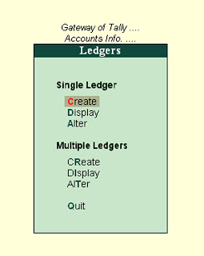
Here Type Capital A/c
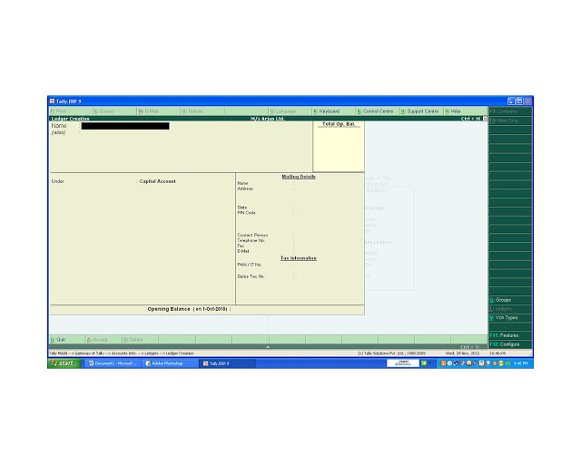

Then select Capital Account from the List of Group
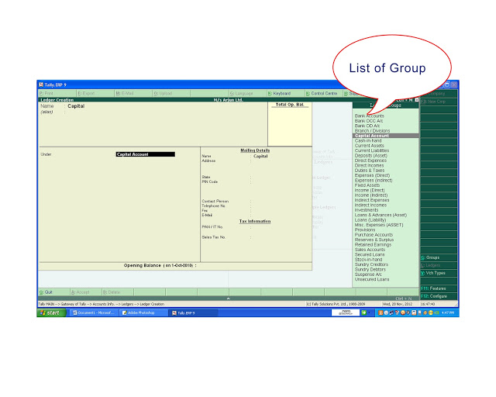
Like this create the following Ledgers
Ledgers | Group
Loan HDFC A/c | Loans Liability
Bank SBT A/c | Bank Account
Furniture A/c | Fixed asset
Furniture Mart A/c | Sundry Creditors
Advertisement A/c | Indirect Expense
Media Advertiser A/c | Sundry Creditors
Printing charge A/c | Indirect Expense
Machinery A/c | Fixed asset
Purchase A/c | Purchase Accounts
Aroma traders A/c | Sundry Creditors
Telephone charge A/c | Indirect Expense
Sales A/c | Sales Account
Purchase Return A/c | Purchase Accounts
Kishore A/c | Sundry Debtor
Sales Return A/c | Sales Account
Drawings A/c | Capital Account
Salary A/c | Indirect Expense
After that Press Esc key for Quit Ledger Creation window
Then from Gateway of Tally Select Accounting Vouchers
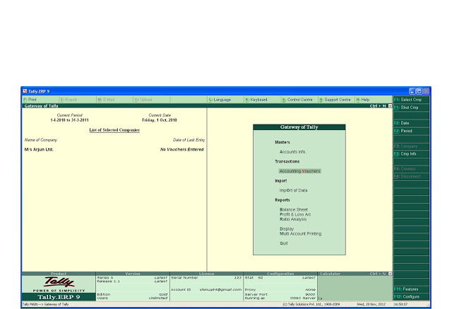

Then you will get:-

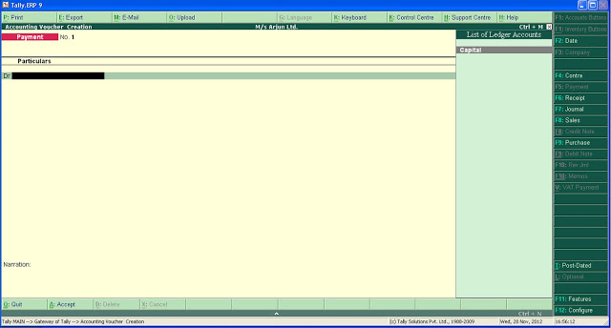
This is called Vouchers. . On the Button Panel you can see the different type of vouchers.
F4 – Contra (To record transaction between Cash and Bank. i.e. Cash deposited into Bank and Cash withdrawn from Bank for office use.)
F5 – Payment (To record Cash and Bank Payments)
F6 – Receipt (To record Cash and Bank receipts)
F7 – Journal (To record non cash transactions)
F8 – Sales (To record Cash Sales and Credit Sales)
F9 – Purchase (To record Cash and Credit Purchase)
For Sales Return and Purchase Return
Press F11 for features
Then you will get :-
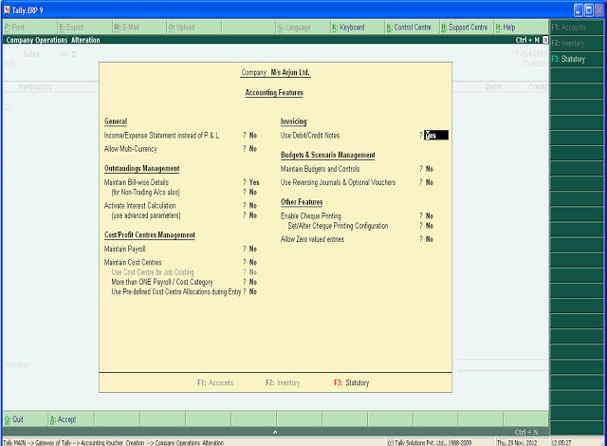

Here select Use Debit/Credit Notes ? Yes
Then Press
Ctrl + F8 – Credit Note (To record sales return)
Ctrl + F9 – Debit Note (To record Purchase return)

See the first transaction
2010 Oct:1 Arjun started a business with cash Rs. 10,00,000
To record this Press F6 for Receipt Voucher. If you want to change the current date Press F2 and give the date
then in
Cr select Capital A/c Type Amount 1000000
Dr select Cash A/c Press Enter Key
Then Give Narration if necessary
Press enter key and accept it.

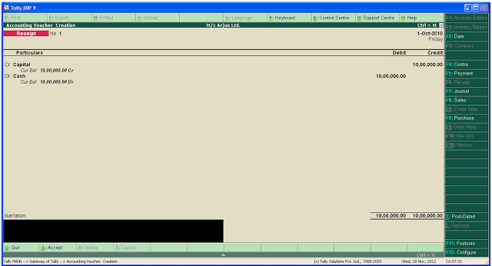

Like that give every transactions

Oct: 2 Received a bank loan from HDFC Bank Rs. 5,00,000
Press F2 then change date

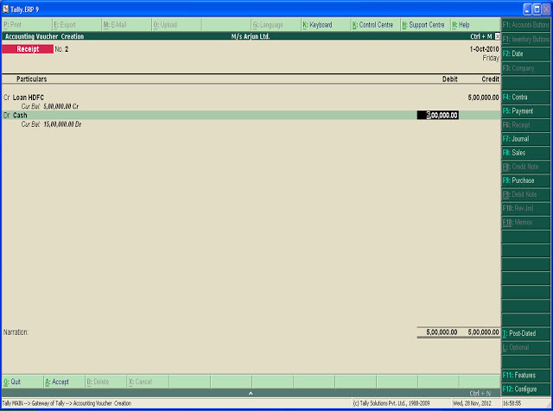

Opened a bank account with Bank SBT Rs. 2,00,000
Press F4 for Contra Voucher

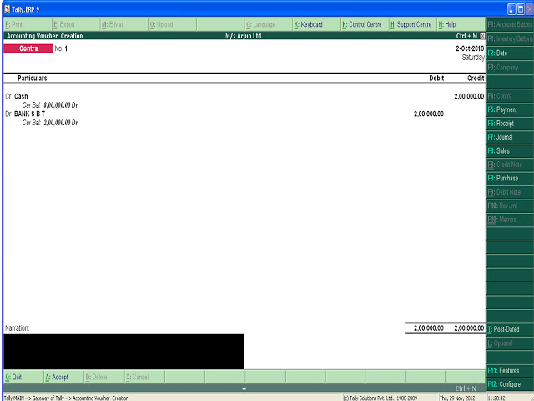

Oct: 3 Bought Furniture from Furniture Mart Rs. Rs. 1,00,000
Press F2 give date
Press F7 for Journal Voucher
Dr Furniture A/c
Cr Furniture Mart A/c
then give bill details and accept it

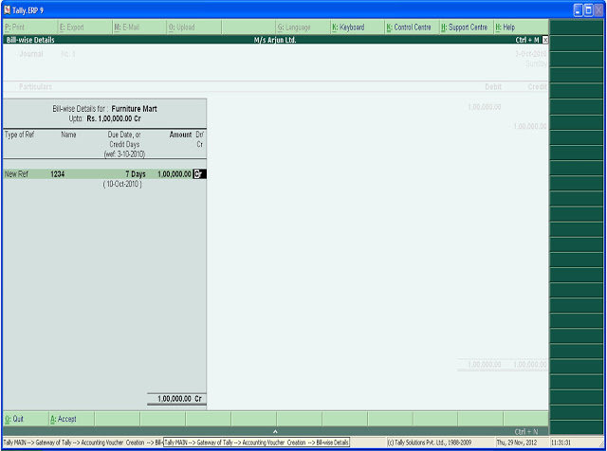

Advertisement payable to Media Advertiser Rs. 1,00,000 (Inv. No. 1284, due days 10 days)
Press F7 for Journal Voucher

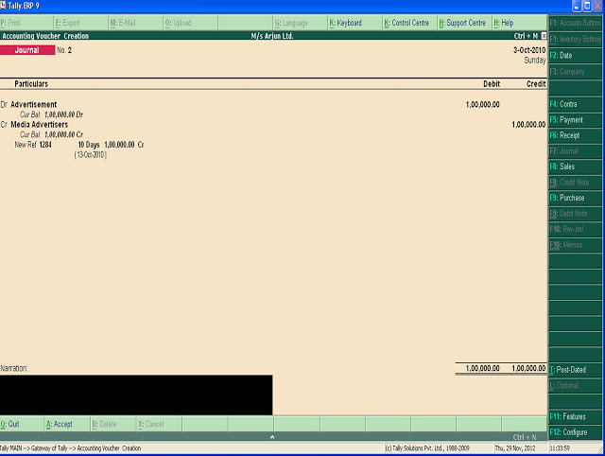

Oct: 4 Paid printing charge Rs. 500
press F5 for Payment Voucher and change date

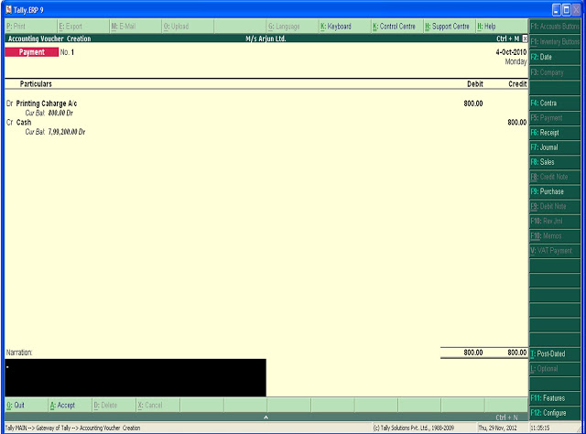

Bought Machinery Rs. 1,20,000

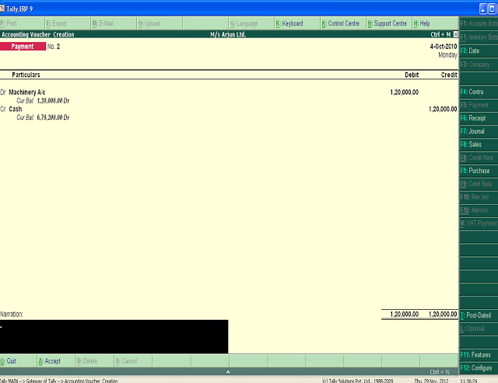

Oct: 5 Purchased goods from Aroma Traders Rs. 85,000 (bill No: 108)
Press F9 (Purchase)
then Press F2 for change date
Cr Aroma Traders A/c
Dr Purchase A/c
Oct: 6 Telephone charge paid by SBT cheque Rs. 1800 (Ch No:123456789)
Press F2 give date

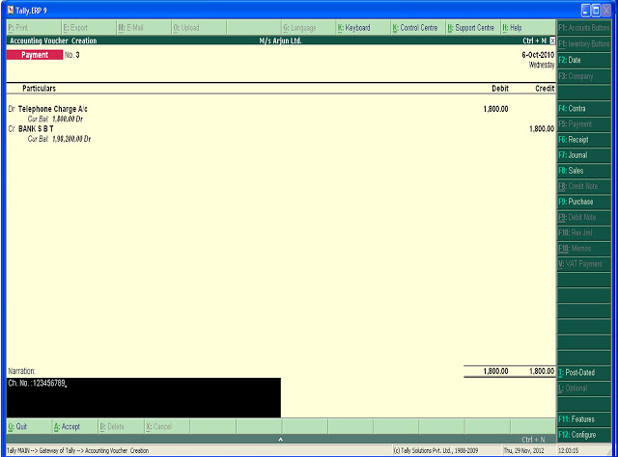

Oct: 7 Cash sales Rs. 50,000
Press F8 then press Ctrl + V to change format of sales voucher. i.e. invoice mode to debtor creditor mode
then give
Dr Cash A/c
Cr Sales A/c

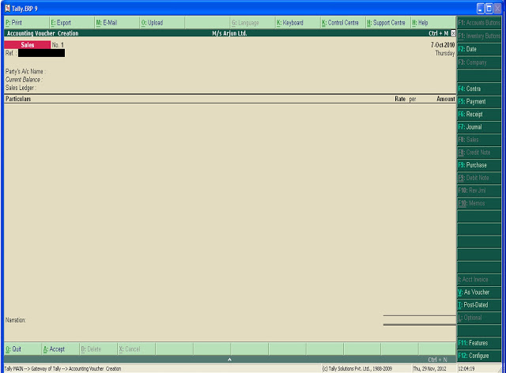

Oct: 8 Goods returned to Aroma traders Rs. 5,000 (agst Bill No: 108)
Press F11 features activate Use debit/credit note Yes

then Press Ctrl + F9 Debit Note for Purchase Return
then select
Dr Aroma traders A/c
Cr Purchase Return A/c
give Bill details agst then select the bill no.
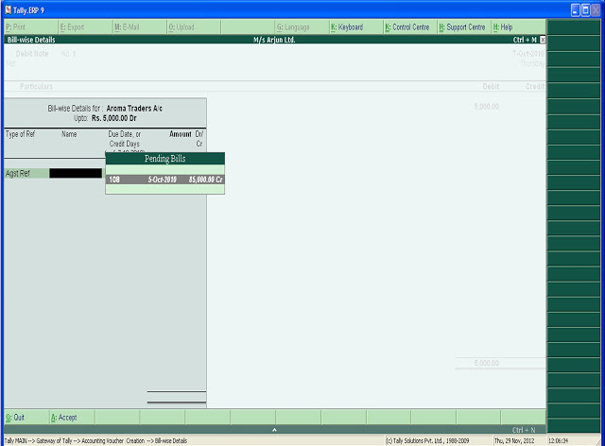

Oct:10Cash paid to Aroma Traders Rs. 25,000 (Bill 108)
Press F5 for Payment Voucher
Press F2 and give the date
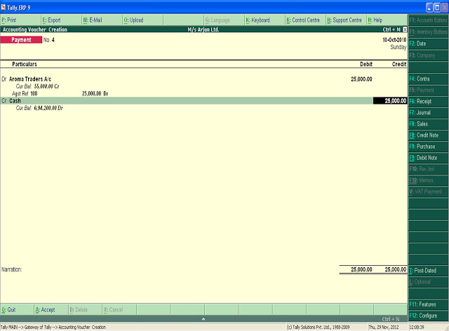
Here select the bill details agst ref then select the bill No.
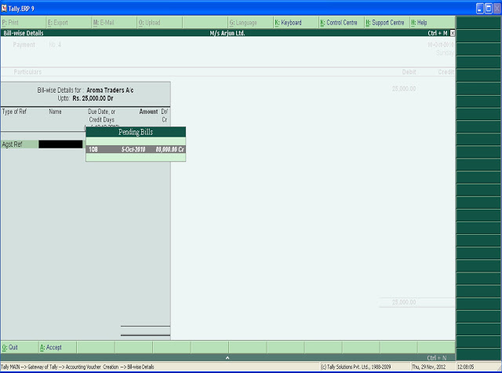

Oct: 11Sold goods to Kishore Rs. 40,000 ( Bill No: 2)
Press F8 for sales voucher
Press F2 and give date
Dr Kishor A/c
in bill wise details select New Ref
Cr Sales A/c
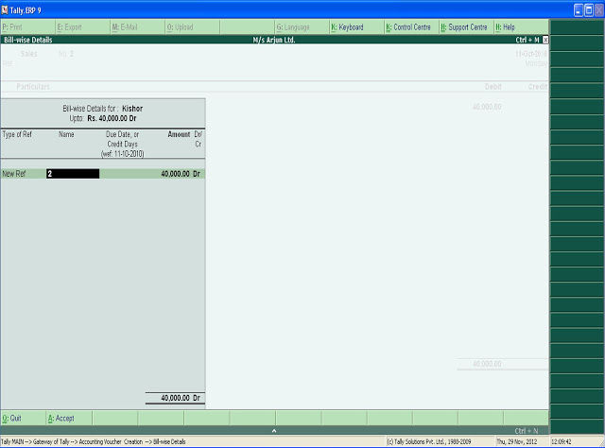

Oct: 13Goods returned from Kishore Rs. 5,000 (Bill No: 2)
Press Ctrl + F8 for Credit Note ( Sales Return)
Press F2 Change Date
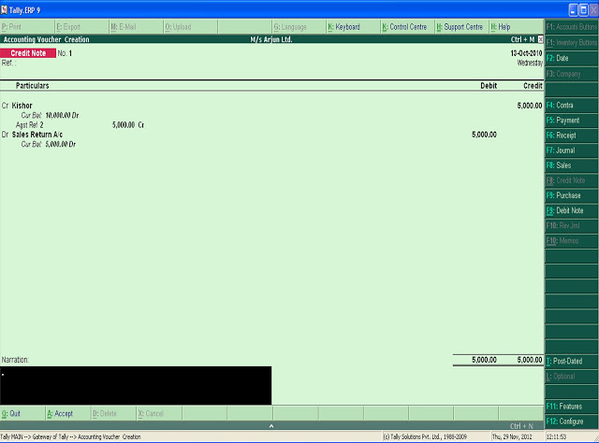
Oct:15Cash withdrawn from SBT Bank Rs. 10,000
Press F4 for Contra Voucher
Press F2- Change Date
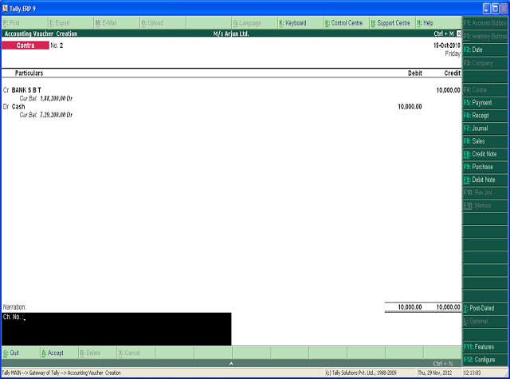

Oct: 16 Paid loan of HDFC Rs. 1,00,000
Press F5 for Payment
Press F2 for date

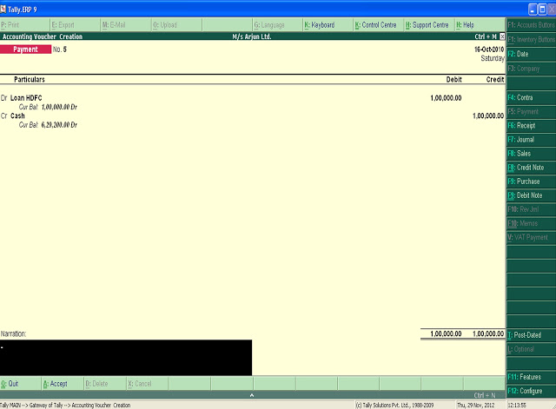

Oct: 17 Cheque of Bank SBT issued to Furniture Mart Rs. 50,000
In Payment Voucher Press F2 for change date
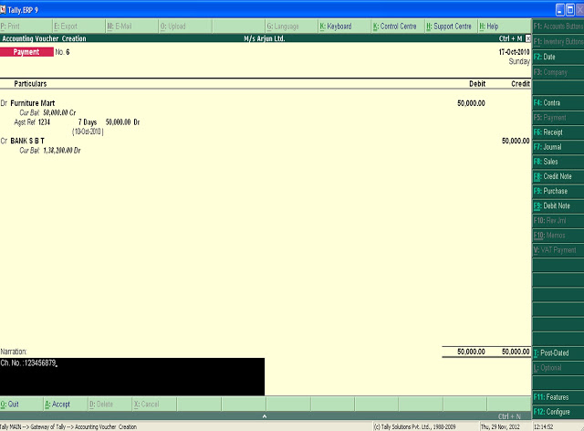

Oct: 18 SBT Cheque issued to Media Advertiser Rs. 50,000

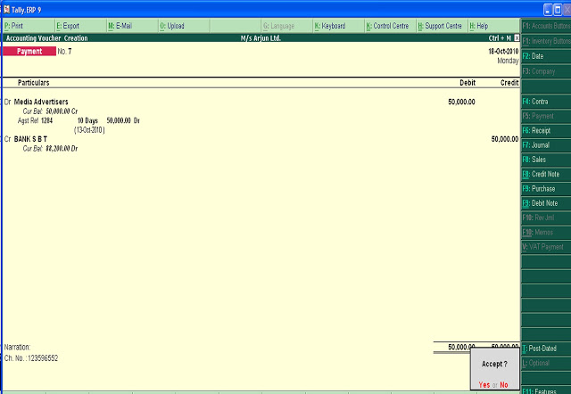

Oct: 25 Cash withdrawn from SBT Bank for personal use Rs. 5,000

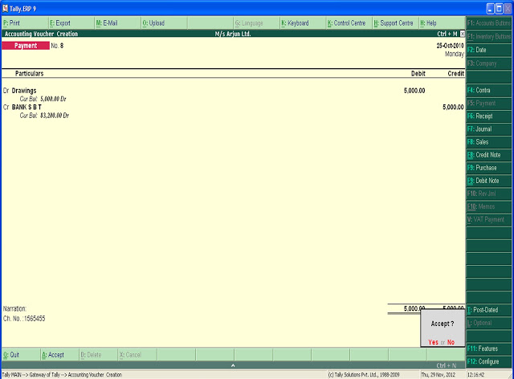

Oct: 30 Paid salary Rs. 12,000




