Sales and Distribution – Billing

SPRO-> Sales and Distribution -> Billing

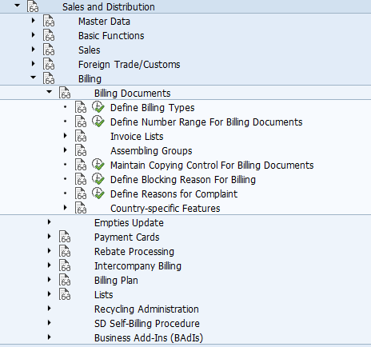

The billing document has a header and item level but no schedule line level. The billing document type is created using following menu path. (tcode: vofa)

Billing -> Billing Document -> Define Billing Types
The SAP Standard uses the following billing types:
F1 | Order related Invoice
F2 | Delivery Related invoice
F5 | Pro forma invoice for sales orders
F8 | Pro Forma invoice for deliveries
G2 | Credit Memo
L2 | Debit Memo
RE | Credit for returns
S1 | Cancellation Invoice
S2 | Cancellation Credit memo
IV | Inter-company billing

Create Billing Document Types -> General Control
- SD document category for Invoice is M
- Transaction group 7 for invoice and 8 for pro forma invoice
- The invoice list type represents the document type that may be used to create invoice list for this billing document.
Create Billing Document Types -> Cancellation
- On cancellation of billing document type, system will use Cancellation billing type as well as copying requirements.
- The SAP standard invoice cancellation type for F2 billing document is S1

Billing -> Billing Document -> Maintain Copying Control for Billing Documents

These copy control define copy rules for header and item level between sales documents.
- Header : Overview
- Header : Details
  - Copying requirements: Copying requirements are routines that check certain requirements as a precondition for the copying process. For example, a copy requirement can be used to define whether a quotation may be copied into a standard order, or if text items are transferred during the copying of a delivery into a billing document. Copy requirements are an easy way to implement company specific business rules into R/3 that dictate situations that should prevent subsequent document creation.
The tcode VOFM lists the routines for copying requirements, data transfer, requirements, and formulas.

- Item : Overview
- Item : Details
  - Use pricing type as G (Copy pricing elements unchanged and re-determine taxes)

Billing Document Creation and Usage

Menu Path : SAP Menu -> Logistics -> Sales and Distribution -> Billing -> Billing Documents
- VF01 – Create
- VF02 – Change
- VF03 - Display

