Delivery Process (Logistics Execution Process)
- Outbound processing to move goods from the plant to the shipping vendor to the customer (posting goods issue). This can be created with reference to a sales order or a scheduling agreements.
- Inbound processing of return of goods (posting goods receipt). This may be created with reference to inbound return sales document
Menu Path
SAP Customizing Implementation Guide | Logistics Execution | Shipping | Deliveries
Delivery Document Type ( OVLK)
Delivery Document Type is the step subsequent to sales document and preceding a billing document. A delivery document has a header and item structure. The output of an delivery is a good movement.
Standard delivery type – LF
The standard delivery document types in ERP ECC are
Standard Delivery | LF
Delivery without reference | LO
Returns Delivery | LR
Returns delivery from purchase order | RL
Replenishment delivery | NL

Delivery Item Category
The delivery item category determines how the system processes an item. The delivery item category checks how the item to be delivered will be handled during the shipping process. The item category is assigned to a document category, for delivery document category is J. Whether the system should check:
- If the item is relevant for delivery
- If the minimum quantity criteria are met
- If the over delivery is prompted at the time of delivery when trying to deliver over and above the sales order quantity
- If the material is relevant for picking or not
- If the storage location is required and mandatory
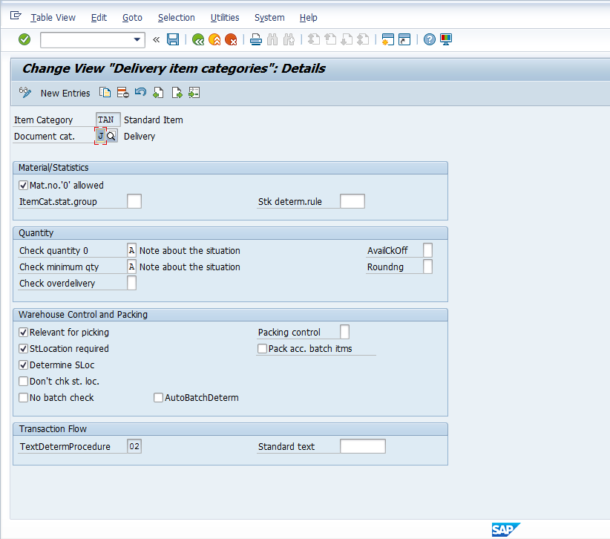

Delivery Item Category Determination
- If an order item or schedule line is copied into a delivery, the item category used in sales order is also copied. For example, if a TAN item category is used in the sales document type, the system will propose a TAN in delivery document as well.
- For items independent of orders in the delivery or for deliveries that have no reference to sales document, the item category is determined by the delivery item category determination table
- Delivery Item category = f( delivery document type, item category group of material, usage of item, item category of high level item)

Delivery Due List
The delivery due list to process deliveries for all order items that are due for delivery at a certain time or within a certain period.
The delivery due list transaction codes are as follows:
VL10A | Sales Order fast display
VL01B | Purchase order fast display
VL10C | Sales Order items
VL10E | Sales Order Schedule Lines

Shipping Point
Shipping point are independent organizational units that are linked to a plant and represent the point of departure or receipt of materials. The shipping point is the location from which the a delivery originates. The shipping point is determined by the system based on the shipping conditions.

Delivery Creation process
VL01N
VL02N
VL03N

