Sales and Distribution - Sales
Sales Documents
Sales document is divided in three levels:
Header Level (Table VBAK) | Customer Data, Sales Area, Organization data. | Controlled by Sales Document Type
Item Level ( Table VBAP) | Material item data, order quantity | Controlled by Sales item category
Schedule Line (Table VBEP) | Delivery date and delivery quantity | Controlled by Schedule line category

Standard SAP SD sales document types
- IN – Inquiry
- QT – Quotation
- OR – Standard Order
- RE – Returns Order
- CR – Credit Memo Request
- DR – Debit Memo Request
- LF – Outbound Delivery Document
- LR – Returns Delivery
- F2 – Sales Invoice
- G2 – Credit Memo
- L2 – Debit Memo
Sales Item Category
The sales item category controls the sales document flow and also impacts the schedule line category. The item category is determined by the system and then can be changed manually in the sale document.
An item category can be defined on the basis of the following questions −

General Data Control Elements
- An item refers to a material or a text item?
- Whether pricing has to be carried out for an item?
- Are schedule lines allowed for an item?
- When the item has to be considered as completed?
- If an item cannot be fully delivered, a message will appear in the system or not?
- Which partner functions are allowed for an item?
- Which output is allowed for business transactions?

Shipping Data Control Elements
- Is the volume and weight of an item determined?
- Whether this Item is relevant for a delivery or not?

Billing Data Control Elements
- Is the item suitable for billing?
- Should the cost of this item be determined?
- Is it a return item?
- Whether it is a statistical item?
Categorization | Description of an Item
TAN | Standard Item
TAB | Individual Purchase Order
TAS | Third Party Item
TAD | Service
TANN | Free of charge item
TATX | Text item
AFX | Inquiry item
AGX | Quotation item
To create an Item − T-Code: VOV4

Item Category Determination
- The system uses the item category group field of the material master record as the main indicator to determine the item category in the sales order
- The item category can be changed manually using “Assign Item category”

https://wiki.scn.sap.com/wiki/display/ERPLO/FUNCTIONALITY+OF+ITEM+CATEGORY

Schedule Line Category
The Schedule line category controls the material requirements planning and execution in shipping. The schedule line category is determined based on the item category and MRP type on material master.
https://www.tutorialspoint.com/sap_sd/sap_sd_schedule_lines_categories.htm

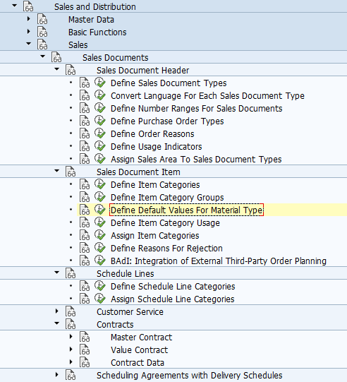

Menu Path: SPRO-> Sales and Distribution -> Sales
Sales -> Sales Documents -> Sales Document Items
1 | Define Item Category | VOV7
3 | Define Item Category Group | OVAW

Sales -> Sales Documents -> Schedule Line Items
4 | Define schedule line categories | VOV6
5 | Assign Schedule Line Category to item category | VOV5

Sales -> Sales Documents -> Sales Document Header

6 | Define Sales Document type | OV8
- Inquiry Document :- EIQ
- Quotation :- EQQ
- Sales Order :- ESO
- Delivery :- EDL
- Billing :- EBL
7 | To assign item categories/item category group to Sales Document Type | VOV4
8 | Assign Sales Area to Sales Document Types | OVAZ
9 | Assign Partner Determination function to Sale Document type | VOPAN

Copy Control
Sales -> Maintain Copy Control For Sales Documents
Billing -> Maintain Copy Control For BIlling
Logistic Execution-> Shipping-> Specify Copy Control For Deliveries
1 | Copy Control from Inquiry to Quotation | VTAA
2 | Copy Control from Quotation to Sales Order | VTAA
3 | To Create Copy Control from Sales document to delivery | VTLA
4 | To Create Copy Control from Delivery to Billing Document | VTFL
5 | Copy Control from Inquiry to Quotation | VTAA

Error: Not possible to determine a consumption account
Solutions:
Go to OMWD, select your material type,then select your valuation area and tick mark in the box of quantity and value updation.

Warning: Caution: This table is cross-client

Sales Documents
SAP Menu-> Logistics -> Sales -> Sales Document ->

Customer not appearing in Inquiry Document.

